Assignment_6.1
K.Pallavi
2303a51243
Batch:18
Task Description #1 (AI-Based Code Completion for Loops) Task: Use an AI code completion tool to generate a loop-based program.
Prompt:
“Generate Python code to print all even numbers between 1 and N using a loop.”
Expected Output:
- AI-generated loop logic.
- Identification of loop type used (for or while).
- Validation with sample inputs. Prompt:
# Generate Python code to print all even numbers between 1 and N using a loop
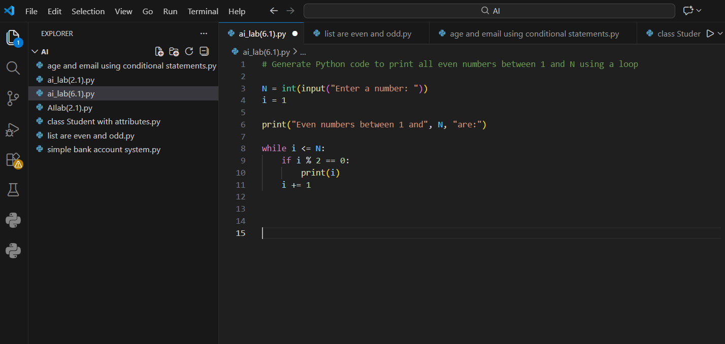

OUTPUT:
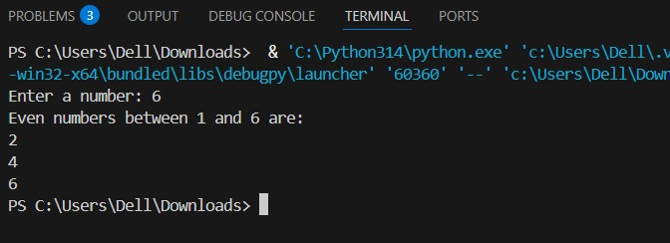
Analysis:
Correct selection of a for loop with step size optimization Logic is clear and efficient

Task Description #2 (AI-Based Code Completion for Loop with Conditionals)
Task: Use an AI code completion tool to combine loops and conditionals.
Prompt:
“Generate Python code to count how many numbers in a list are even and odd.”
Expected Output:
- AI-generated code using loop and if condition.
- Correct count validation.
- Explanation of logic flow. Prompt:
#Generate Python code to count how many numbers in a list are even and odd.

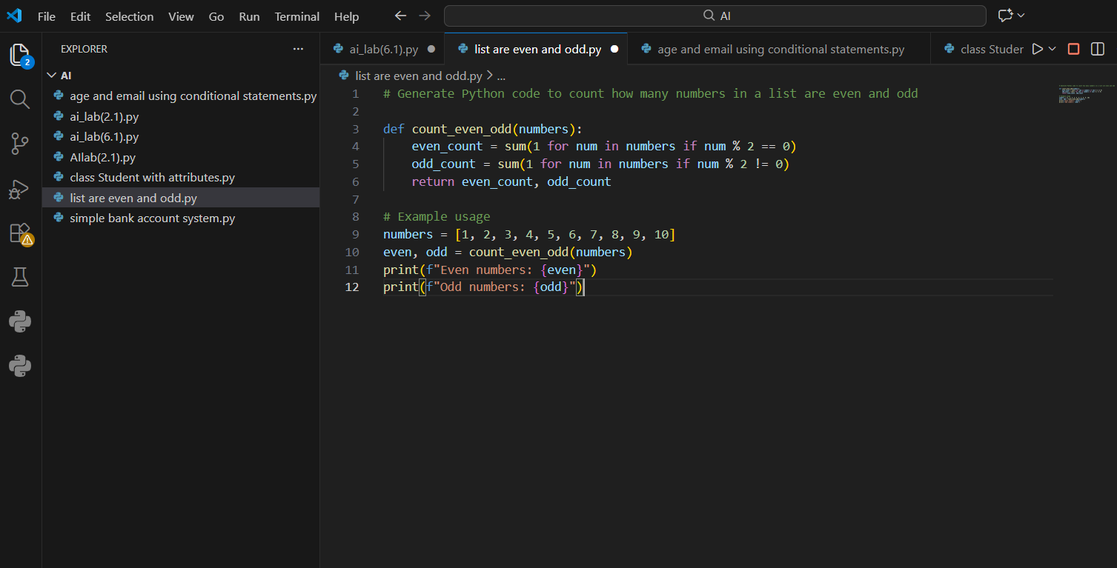
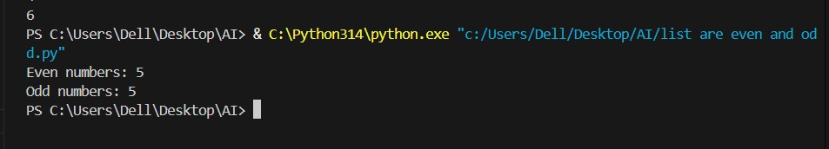
Analysis:
Accurate counting logic
Easy to extend for other classifications

Task Description #3 (AI-Based Code Completion for Class Attributes Validation)
Task: Use an AI tool to complete a Python class that validates user input.
Prompt:
“Generate a Python class User that validates age and email using conditional statements.”
Expected Output:
- AI-generated class with validation logic.
- Verification of condition handling.
- Test cases for valid and invalid inputs. Prompt:
#Generate a Python class User that validates age and email using conditional statements.

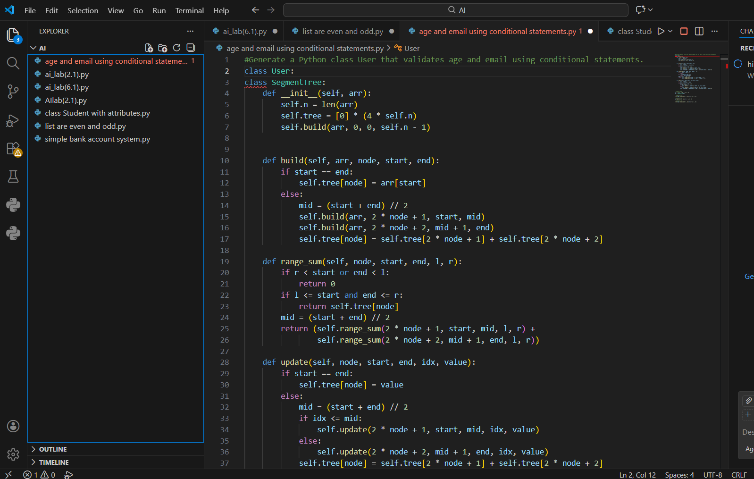
OUTPUT:
Analysis:
Correct use of constructor for validation Clear error handling via exceptions

Task Description #4 (AI-Based Code Completion for Classes)
Task: Use an AI code completion tool to generate a Python class for managing student details.
Prompt:
“Generate a Python class Student with attributes (name, roll number, marks) and methods to calculate total and average marks.”
Expected Output:
- AI-generated class code.
- Verification of correctness and completeness of class structure.
- Minor manual improvements (if needed) with justification. Prompt:
#Generate a Python class Student with attributes (name, roll number, marks) and methods to calculate total and average marks.

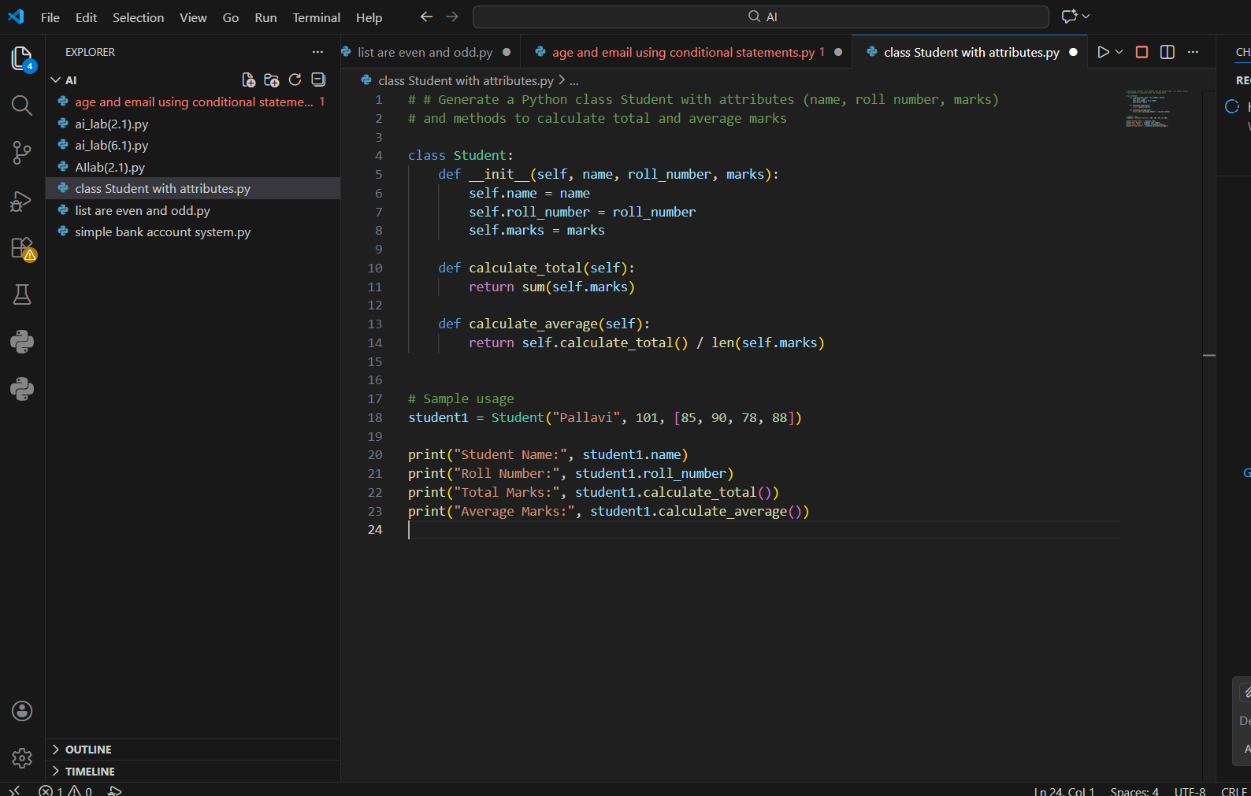

OUTPUT:
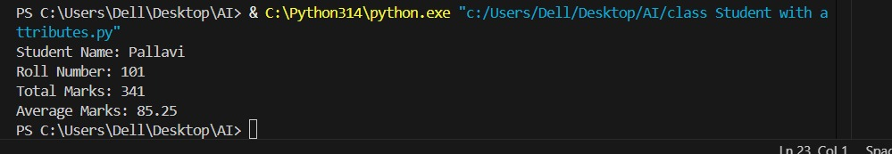
Analysis:
Logical separation of data and behavior Reusability improved by method reuse Code is readable and maintainable

Task Description 5 (AI-Assisted Code Completion Review)
Task: Use an AI tool to generate a complete Python program using classes, loops, and conditionals together.
Prompt:
“Generate a Python program for a simple bank account system using class, loops, and conditional statements.”
Expected Output:
- Complete AI-generated program.
- Identification of strengths and limitations of AI suggestions.
- Reflection on how AI assisted coding productivity. Prompt:
#Generate a Python program for a simple bank account system using class, loops, and conditional statements.
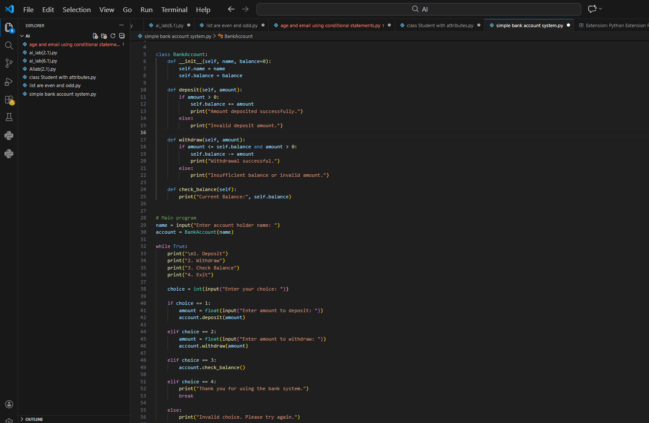

Output:

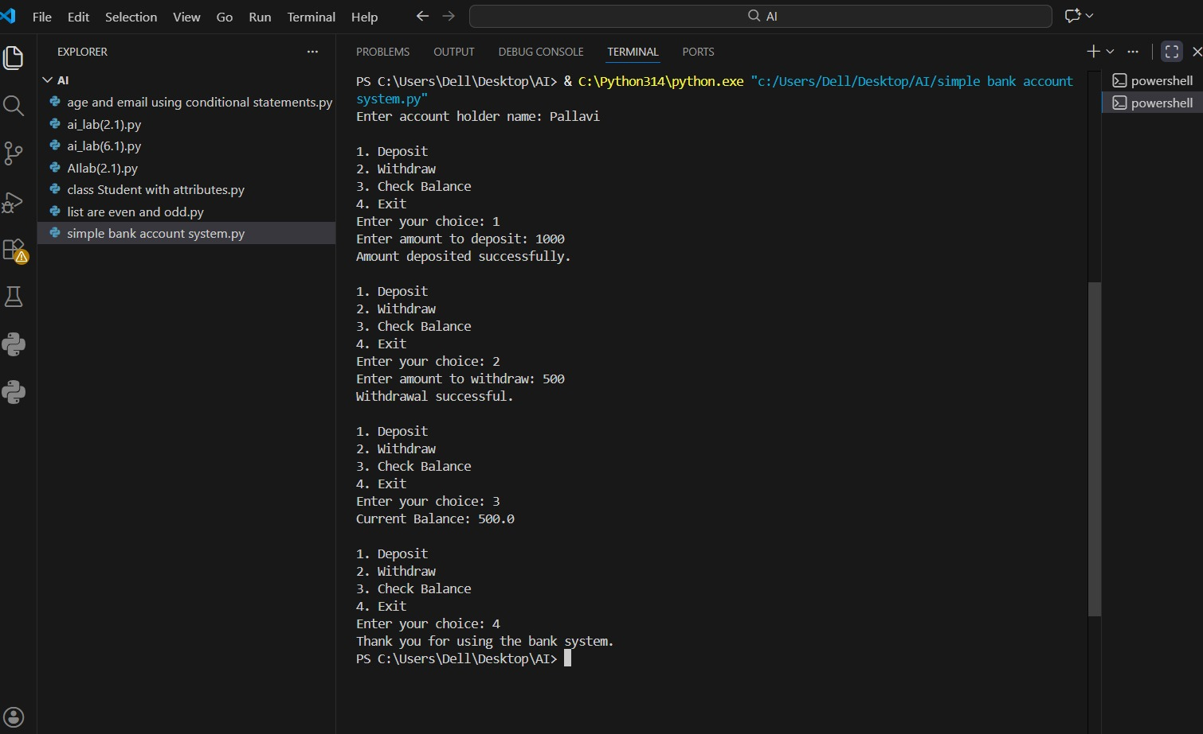
Analysis:
Real-world inspired example
Demonstrates program flow clearly

